Paul J. Mokrzecki
Vice Chair

Mary A. Stokarski
Elected Member

Dale C. Kowacki
Executive Director
Sandra A. Hanks
Board Chair

Angelina J. Bragdon
Council Member

Gabriele H. Voelker
Elected Member

Annual Report for the Calendar Year Ending December 31, 2018

To the reader:

The Franklin Regional Retirement System is a government agency that serves the 580 retirees, 53 beneficiaries, 1,023 active employees, and 604 inactive members of the towns and agencies in Franklin County. We are organized under Chapter 34b, and subject to the provisions of Chapter 32 of the Massachusetts General Laws. We receive oversight on the state level from the Public Employee Retirement Administration Commission (PERAC). We contract with an independent auditor to do a full audit of our system each year. We also contract with an actuary to perform a complete actuarial valuation every two years. PERAC audits our operations and financial records every three years.

The retirement benefit we provide replaces participation in the Social Security system and is described as a “defined benefit”, which means that we pay monthly retirement benefits based on the age, salary, and number of years worked at the time a member of our system retires. To be a member, an employee in one of our government units must be working in a permanent position scheduled at 20 hours or more per week and earning $5,000 or greater annually. Funding of these benefits begins with deductions from the member, and, combined with matching funds from the employing unit, are invested in a mix of stocks, bonds, and indexed funds. Investment earnings are a large part of the funding of retirement benefits, and the allocation of those funds are spread to a variety of sectors to take advantage of positive activity as it occurs in each sector. Please make note of our investment performance percentages in the chart on the next page.

Up until 1988, we were a “pay-as-you-go” system. In 1988 it was legislated that we begin saving to become “fully funded” over the ensuing 40 years. Fully funded means we have enough in reserves to pay for all the current and future potential benefits of our present membership. At the end of 2018, we are 73.2% funded at 30 years (75%) into the 40 year mandate.

Our fiscal year is the calendar year, therefore our annual report is not filed until May of the subsequent year, and as a consequence the information provided herein will be a year old by the time you read this. Current reports and information can be found on our website: www.FRRSMA.com.

What follows is a synopsis of our annual report, as filed with our State oversight commission, PERAC. The full PERAC report can be read on the “Finances” page of our website.

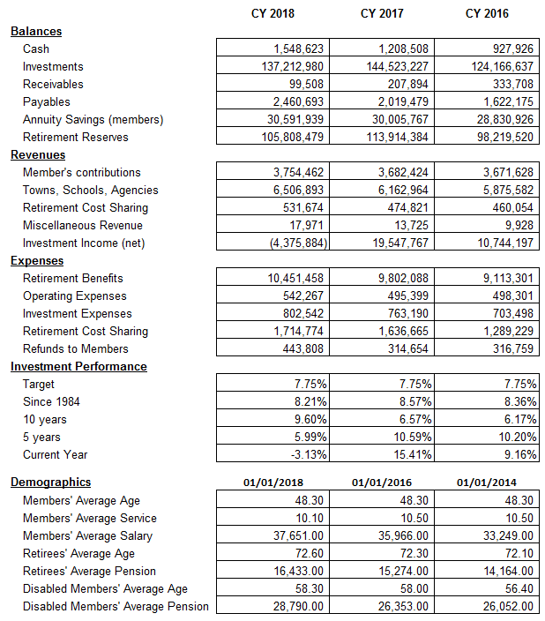

Dale Kowacki
Executive Director
Franklin Regional Retirement System

